Study Protocol
Human Digital Twin Intelligence: Integrating Multimodal AI and Generative Models for Non-Intrusive Health and Activity Monitoring.

Introduction
Participants will be welcomed to the AUT WZ Level 1 Engineering Laboratory. A member of the research team will explain the study procedures in detail, and you will have time to ask any questions before deciding whether to take part and signing the consent form. In this study, we will use Depth camera and radar sensors to remotely capture activities and measure vital signs. You will also be asked to wear a Hexoskin smart vest and small inertial measurement unit sensors, known as IMU sensors, which record body movement and vital signs while you perform a set of functional physical activities. The information collected will be used to develop artificial intelligence models, including deep learning models, to recognize human activities and monitor vital signs. Your data will help us develop a multimodal and generative AI model for human activity recognition and non-intrusive health monitoring.

Attachment Accelerometers/Wearable camera
Five IMU sensors will be used in this study. The placement of these sensors is as follows:
- Lower back (attached using medical tape)
- Thigh (attached using medical tape)
- Waist (secured using an elastic belt)
- Wrist of your dominant hand (attached using a wristband)
- Ankle of your dominant leg (attached using an ankle strap)
An IMU Sensor A Hexoskin Smart Vest
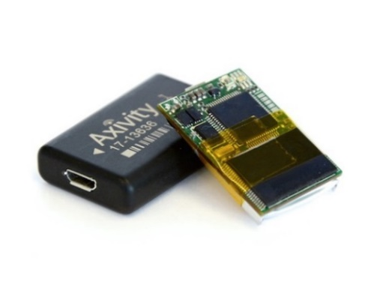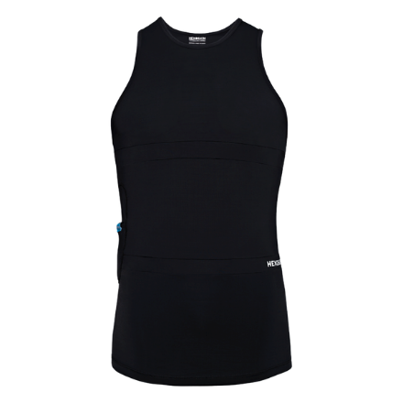

Verbal introduction
“First, we will ask you to wear a Hexoskin smart vest. The vest records vital signs such as your breathing rate and heart rate during the study. Vests are available in men’s and women’s styles and in a range of sizes, so you can choose the one that fits you best. All vests have been sanitised before use. You may use the toilets on this floor to change in private.”
“Next, we will attach five small motion sensors, called Inertial Measurement Units (IMUs), to measure your movements based on acceleration and angular velocity in six dimensions. These will be placed on your lower back, thigh, waist, wrist, and ankle. We will use medical tape to attach the lower back and thigh sensors, an elastic belt for the waist sensor, a wristband for the wrist sensor (on your dominant hand), and a strap for the ankle sensor (on your dominant leg). Before we place the sensors, we will clean the area with an alcohol wipe to ensure proper adhesion."
Participants will be shown an instructional diagram (Show Card) of sensor placement before proceeding.

SHOW CARD

Figure 1. Locations of IMU sensor placements
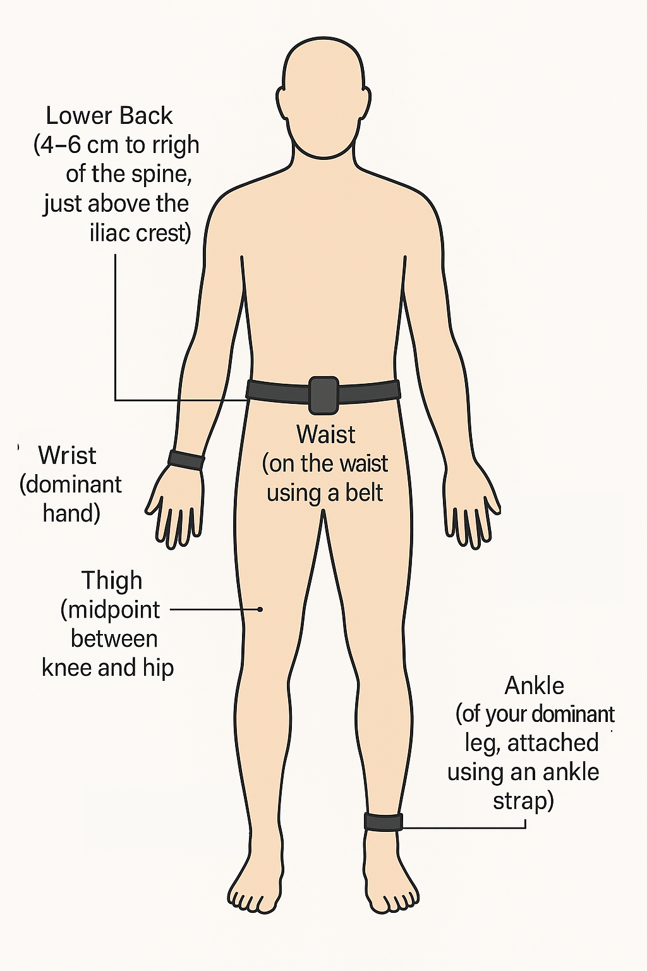 | 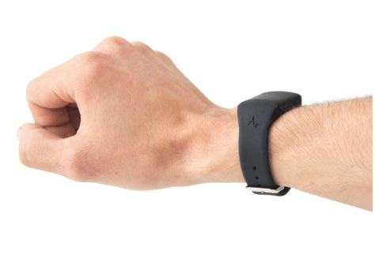  Wrist Sensor
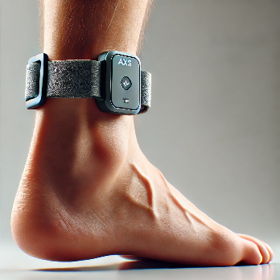
Ankle sensor

Figure 2. Lower back and thigh sensors attached using tapes
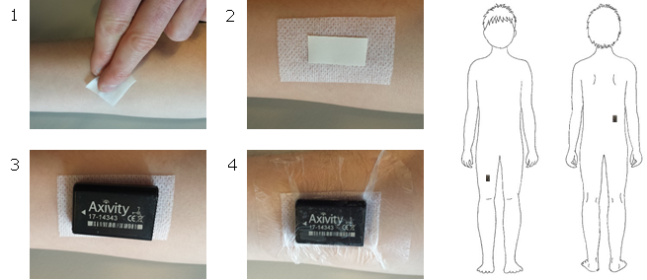

Detailed Sensor Placement Protocol (Thigh, Lower Back, and Waist)

Placement of IMU on the Thigh
- Ensure the participant is wearing suitable clothing (e.g., shorts or flexible pants).
- Ask the participant to sit down and expose the thigh.
- Identify the midpoint between the knee and hip.
- Clean the area with an alcohol wipe and allow it to dry.
- Apply the medical-grade adhesive tape to the skin.
- Remove the protective layer from the adhesive tape.
- Attach the IMU sensor with the arrow pointing toward the knee.
- Secure the sensor with transparent overlay tape.

Placement of IMU on the Lower Back
- Ask the participant to bend forward slightly.
- Identify a location 4–6 cm to the right of the spine, just above the iliac crest.
- Clean the area with an alcohol wipe and allow it to dry.
- Apply the medical-grade adhesive tape to the skin.
- Remove the protective layer from the adhesive tape.
- Attach the IMU sensor with the arrow pointing downward.
- Secure the sensor with transparent overlay tape.

Placement of IMU on the Waist
- Attach the IMU sensor to an elastic belt.
- Fasten the belt securely around the participant’s waist.

Activity Trials
Participants will perform common functional movements in a controlled laboratory setting. Each activity block will generally last about 1-3 minutes, or a small number of repetitions as specified below. Short rest breaks of approximately 30-60 seconds will be provided between activities, and longer rest breaks will be provided if requested. Activities may be skipped or stopped at any time.

A fixed video recording system will capture ground-truth activities to generate labels for the sensor data and validate AI models. The fixed camera is not worn by the participant. Radar devices will be positioned approximately 3 m from the participant, where feasible, to record non-contact radar signals during the same activity trials.

No. | Movement | Standardised instruction | Duration/repetitions | Safety/notes
1 | Seated baseline | Participant sits upright on a chair with feet on the floor and arms relaxed. | Approximately 2 minutes. | Used for baseline physiological and radar signals.
2 | Standing still baseline | Participant stands upright in a comfortable stance with arms relaxed. | Approximately 2 minutes. | Researcher remains nearby for safety.
3 | Sit-to-stand transition | Participant begins seated on a standard chair, stands up fully, then sits back down in a controlled manner. | 5 repetitions or approximately 1 minute. | Participant may use a comfortable pace; arms may be relaxed or used for balance if needed.
4 | Normal walking | Participant walks along a marked indoor path at a comfortable self-selected speed and turns safely at the end. | Approximately 2 minutes. | Path kept clear of obstacles.
5 | Fast-paced walking | Participant walks along the same marked path at a brisk but safe pace. | Approximately 1-2 minutes. | Not running; participant may slow down or stop at any time.
6 | Step-ups | Participant steps up and down on a stable low platform. | Approximately 10 repetitions. | Platform height approximately 15-20 cm; hand support may be used if needed.
7 | Squats | Participant stands with feet about shoulder-width apart, bends at the hips and knees into a partial squat, then returns to standing. | 5-10 repetitions. | Depth limited to participant comfort; no added weight.
8 | Lunges | Participant performs controlled forward lunges, alternating legs where comfortable. | Approximately 5 repetitions per leg. | Participant may reduce range of motion or skip the activity.
10 | Carrying an object while walking | Participant carries a light non-fragile object while walking along the marked path. | Approximately 1-2 minutes. | Object approximately 2 kg or lighter if preferred.
11 | Bending and picking up an object | Participant bends at the hips and knees to pick up a light object from a low surface or floor and returns to standing. | 5 repetitions. | Researcher demonstrates safe technique; object is light and non-fragile.

The research team will guide participants through the activities using consistent verbal instructions. The order of activities may be adjusted for safety or practicality, but deviations will be recorded. If a participant feels discomfort, fatigue, embarrassment, or concern, they may take a break, skip an activity, ask for camera/radar recording to be turned off, or stop the session.

Removing the Sensors
At the end of the session, participants will remove the sensors with assistance from the research team. Any residual adhesive will be cleaned from the skin. The session is expected to take approximately 1 hour.

Data Collection and Storage
Data from depth camera, radar, and IMU sensors will be synchronized with video recordings and Hexoskin vest data to validate our AI models for human activity recognition and vital sign estimation. All data will be stored in a secure, anonymized format for research purposes.

Follow-Up
Participants may be contacted for any follow-up clarifications if needed. They may also request a summary of the research findings at the conclusion of the study.

